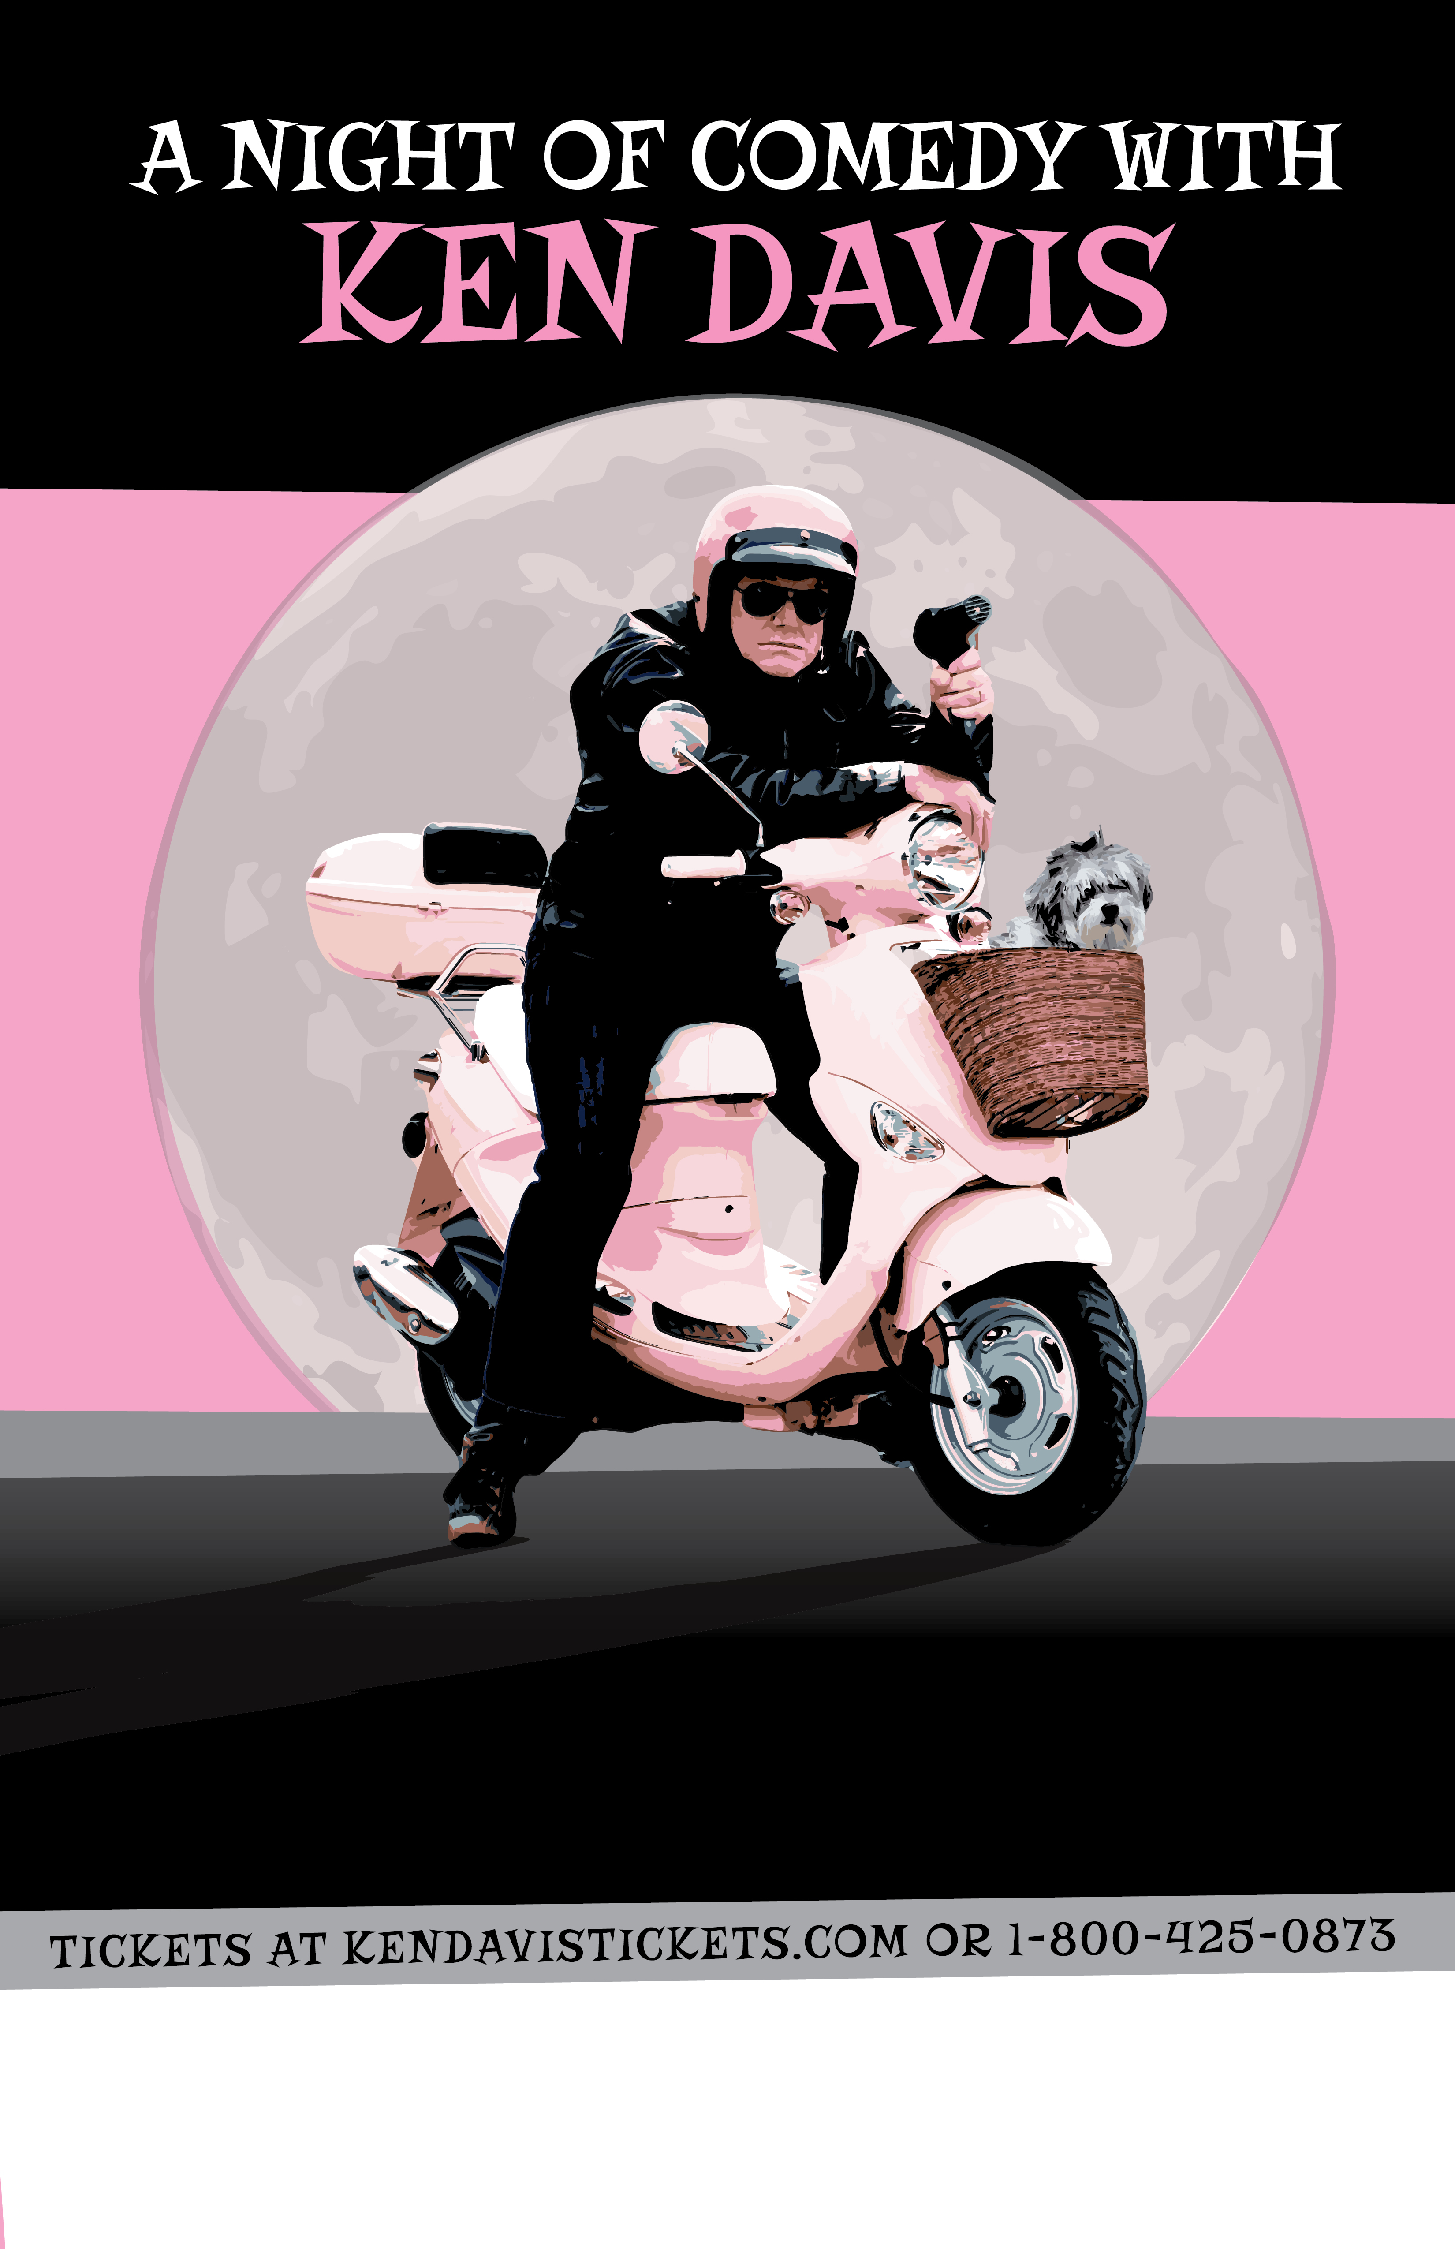­­­

Day, Month X, 2014 | X:XXpm

Venue Name, Address here, City, State Zip

Doors Open at XX:XX